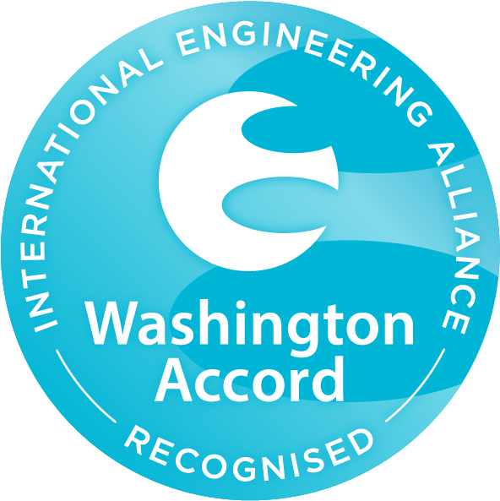  Internationally Recognized  UET Graduates are eligible to work globally as it is associated to Washington Accord. Programs offered in Computer Science Department are recognized by Washington Accord | 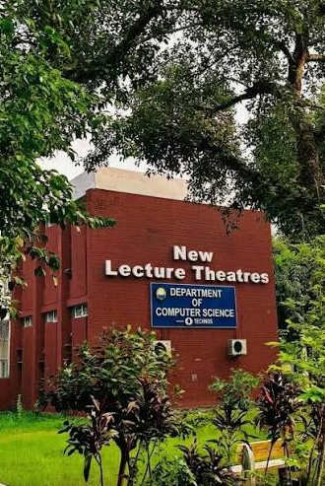  Visit Us Online  lms.uet.edu.pk  cse.uet.edu.pk  uet.acm@gmail.com | 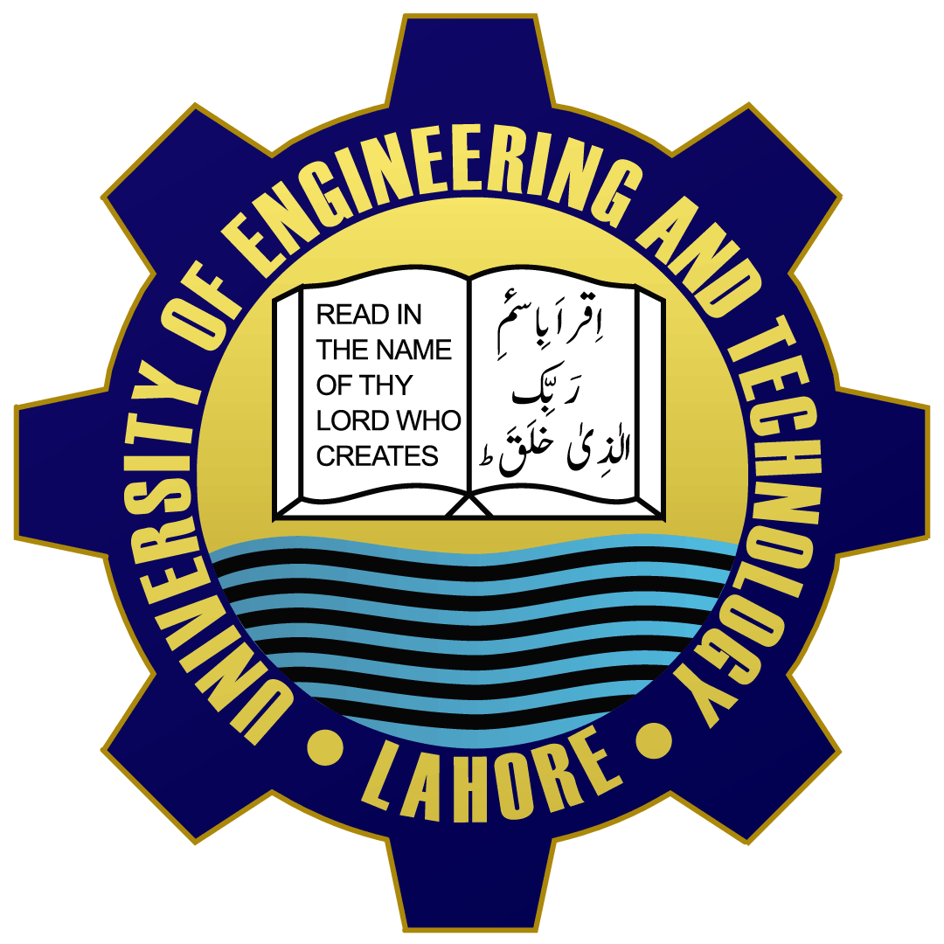  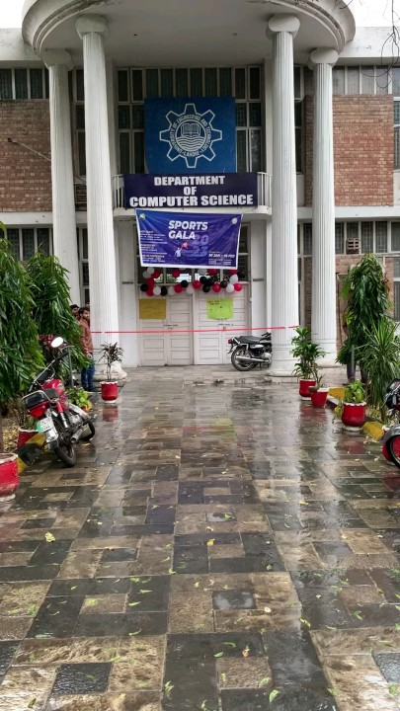  Department of Computer Science and Engineering, UET Lahore

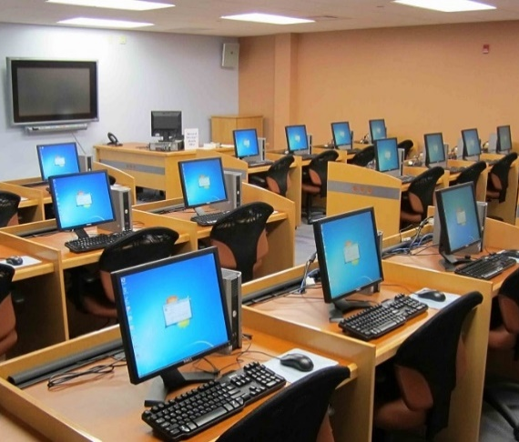  Careers  Courses Offered  - BSc Computer Engineering  - BSc Computer Science  - MSc Computer Engineering  - MSc Computer Science  - Software Development  - Network & Computer System Administrators  - Computer Network & Architects | Computer Cell is providing complete facilities with advance internet service to whole universities  Computer Facilities  💻 IEE UET Society  💻 Computer Club  💻 IET Society  UET ACM is one of the most celebrated scientific society which is actively participated in different events in collaboration with ICOSST (KICS)  Technical Society  Edward Teller  The Science of Today is the Technology of Tomorrow | UET Admissions: 042-99029216  Registrar: 042-99029227  Deputy Registrar: 042-9902909  Assistant Registrar: 042-99029417  Contact Us  Dean: Prof. Dr. Suhail Aftab Quraishi  Chairman: Prof. Dr. Muhammad Shahbaz

© 2026 Muhammad Alliyan Fahad. All rights reserved.
This document and its original content are the work of the author and may not be reproduced, distributed, or submitted as another person's work without permission.

